Unite
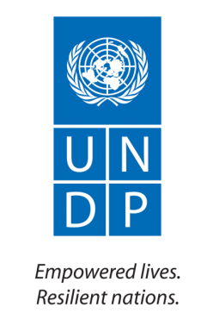
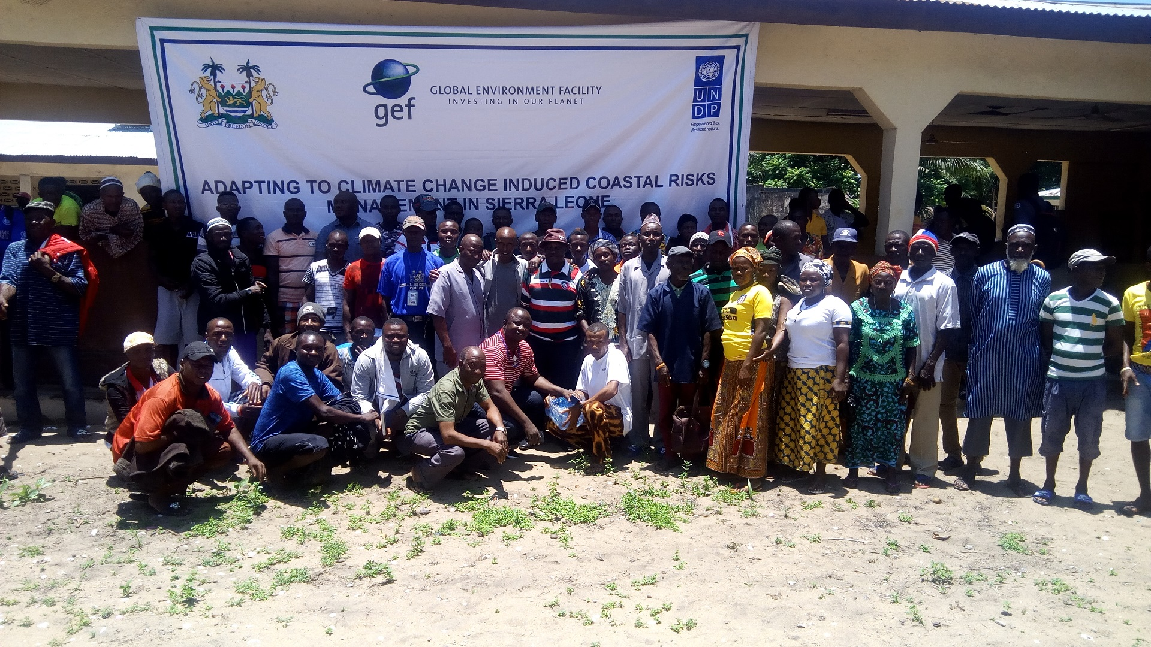d
United Nations development Programme
Sierra Leone
Project Title: Adapting to climate change induced coastal risks management in Sierra Leone
Annual Progress Report, 2018

20101X

Acronyms

UNDP : United Nations Development Programme
EPA: Environmental Protection Agency
NTB: National Tourist Board
MFMR: Ministry of Fisheries and Marine Resources
MDAs: Ministry Department and Agencies
IPs: Implementing Partners
WA BiCC West Africa Biodiversity and Climate Change program

Table of Contents

I. Project Status Information 4
II. Executive Summary 5
III. Indicators Based Performance Assessment 6
IV. Results 7
V. RISKS AND ISSUES 9
VI. Partnerships 11
VII. Challenges Lessons learned and Recommendations 11
VIII. Financial report 2018 12
IX. Monitoring and Evaluation 15
X. Annexes 16

Project Status Information

Project title | Adapting to climate change induced coastal risks management in Sierra Leone
Project ID | 00104509
Project start Date / end Date | April, 2018/March, 2023
Implementing Modality | Direct Implementation Modality (DIM)
Implementing Partner(s) | UNDP
Cluster name | Inclusive Growth and Sustainable Environment
Donors | Global Environment Facilities (GEF)

Project Objective | Strengthen the ability of coastal communities to systematically manage climate change risks and impacts on physical infrastructure and economic livelihoods
UNDP RPD outcome / UNDP Strategic Plan RRF outcome | Output 1.3: Solutions developed at national and sub-national levels for sustainable management of natural resources, ecosystem services, chemicals and waste.  Output 1.4: Scaled up action on climate change adaptation and mitigation cross sectors which is funded and implemented.  Output 1.5: Inclusive and sustainable solutions adopted to achieve increased energy efficiency and universal modern energy access (especially off-grid sources of renewable energy)  Output 2.5: Legal and regulatory frameworks, policies and institutions enabled to ensure the conservation, sustainable use, and access and benefit sharing of natural resources, biodiversity and ecosystems, in line with international conventions and national legislation.

Annual Budget  (US$) | Expenses as of: 15/01/18  (US$) | expenses  (% of annual budget)
250,600 | 190,832 | 77

Project Budget  (US$) | Total Project expenses  (US$) | Project Balance  (US$) | Total expenses  (% of total budget)
10,165,000 | 246,939 | 3,661 | 2.4

Executive Summary
The coastal and marine ecosystems support a wide range of marine living resources that are vital in sustaining the livelihoods of coastal communities, contributing to food security and poverty reduction at the national level. It also supports the productivity of diverse ecosystems including mangroves which are known to contribute to the development of fisheries by serving as fish breeding grounds. The coastal area along the capital of Sierra Leone (Freetown) peninsular contains very beautiful beaches which enhance tourism development and holds substantial number of hotels and tourist resorts and contributes significantly to national economy. However, the environmental and socio-economic impacts resulting from anthropogenic activity and green-house effect are becoming alarming and tremendous along the coastal zones of Sierra Leone affecting the livelihood of communities.
Adapting to climate change induced coastal risk management in Sierra Leone is a five-year GEF funded project implemented by UNDP aimed to strengthen the ability of coastal communities to systemically manage climate change risks and impacts on their physical infrastructure and economic livelihoods in Sierra Leone. The project identified four key partners (EPA, IMBO, MFMR & NTB) as primary stakeholders in its implementation in six locations (Lakka, Hamilton, ConakryDee, Tombo. Seghen and Turtle Island). A national inception workshop was held at Golden Tulip on the 19th July 2018 to officially communicate to stakeholders about the project. Morethan 60 participants were in attendance including two female Honorable Ministers from Ministries of Fisheries and Tourism who served as guest speakers. Both Ministers committed their support in ensuring a successful implementation of the project. Communities were also sensitized on the project in all the six project locations.
To enhance the availability of high quality climatic information that allow decision-makers to make critical decision that affect the coastal zones for national development, IMBO conducted two subsequent training workshops in November on global climate change and satellite remote sensing. The training targeted 30 participants each from relevant MDAs to build their capacity in weather and marine monitoring and foresting. In addition, EPA conducted preliminary vulnerability assessment for the six project locations to understand the level of vulnerability of both community and infrastructures. Moreover, MFMR and NTB undertook training of trainers’ workshop each in the six project sites to raise the awareness of community stakeholders on the unsustainable fishing and land management practices respectively. Communication strategy/massages is designed and develop by both partners to increase the knowledge of communities and to build resilience among coastal communities on the risks of climate change.
During the project implementation, coordination among IPs was challenging especially when they were required to open a project account to enhance accountability. However, coordination and collaboration mechanism among IPs was increased to enhance effective implementation.

.

Indicators Based Performance Assessment

Indicators | Baseline | Target | Achieved Target (current Status) | Reasons for Valiance | Source of Verification
Project Results 1: Enhance the availability of high quality climate risk information that is critical for development decision-making in the coastal zone
Output 1.2: Institutional capacity of MFMR, EPA-SL, SLMD/A, ONS, SLMA and USL-IMBO for assessing coastal hazard risk and vulnerability to climate change through probabilistic modelling is strengthened
# of staff from targeted institutions capacitated in coastal hazard risks & vulnerability assessment by Dec. 2018 | Currently staff of targeted institutions lack capacity to carryout coastal hazard risks assessment through probabilistic modelling | 12 Technical staff to be trained by Dec. 2018 | 30 technicians trained by IMBO on Drivers of Global Climate Change and remote sensing techniques | The training targeted both primary and secondary IPs and also institutions that are considered relevant in weather/marine monitoring | Participants list and training report
Project Results 2: Appropriate protection measures, policy, budgeting and legal tools and integrated coordination mechanisms developed to improve and support policy design and implementation in dealing with current and long-term coastal challenges
Output 2: Ecosystem based adaptation design guidance to support future climate resilient planning and development in place
Assessment report on community assets vulnerable to coastal storms for the six project sites available. | Currently there is no community assessment report for the six project locations | Assessment of 6 project locations to be completed by Dec. 2018 | Preliminary assessment on vulnerability of coastal community assets in 6 project locations completed |  | Assessment report, Photos of assets assessed
Project Results 3: Public awareness enhanced and climate resilient alternatives to sand mining promoted for better adhesion of policy makers and communities on adaptation
Output 3.1: An outreach communication, information and awareness strategy designed and implemented to enhance decision-making and foster public awareness
Number of outreach communication, information & awareness strategy formulated & implemented by MFMR & NTB until Dec. 2018 | Currently no outreach communication & awareness raising strategy available | By Dec. 2018, at least 2 outreach communication strategy designed and implemented by MFMR & NTB | -Two outreach strategy developed by NTB on public awareness raising  - Trained 25 Local leaders on climate risks and cost of different adaptation options |  | Activity report, Participants list, copy of outreach strategy

Results

Section 1: Overall results achieved against the outcome
Access to climate-related data underpins the ability of decision-makers to make informed decision and planning regarding climate and marine parameters for any nation. In a bid to strengthened institutional capacity of MDAs, 30 technical staff were trained on global climate change and satellite remote sensing by IMBO. It is hoped that this training will enhance the capacity of technical staff in the various MDAs to gain better understanding to climate and oceanographic data collection and forecasting.

Vulnerability assessment report on community assets vulnerable to coastal storms for the six project sites has been developed. EPA conducted a preliminary assessment on the six project sites to understands the level of asset and infrastructures vulnerable to coastal storm. The assessment report will provide informed decision on further studies to be carried out for the project and assist in designing appropriate protection measures necessary for dealing with the challenges and risks of climate change.

Training of Trainers workshop has been conducted by both NTB and MFMR targeting community stakeholders on public awareness massages/strategies on the negative impact of climate change especially along the coastal zones. This strategies/massages will create awareness among community stakeholders to understand the negative impact of climate change and the effect of unsustainable fisheries and land management and design appropriate adaptation measures/policies for coastal zones.

Section 2: results achieved against Outputs

Output 1.2: Institutional capacity of MFMR, EPA-SL, SLMD/A, ONS, SLMA and USL-IMBO for assessing coastal hazard risk and vulnerability to climate change through probabilistic modelling is strengthened

Activity Result 1.2.1:
Two sets of trainings were conducted in November by IMBO targeting 30 technical staff each from both primary and secondary stakeholders. This training was timely as there is limited institutional capacity among technical staff of the various MDA on undertake climate and oceanographic information. It is hoped that this training will enhance the capacity of technical staff in the various MDAs to gain better understanding on climate and oceanographic information especially collecting reliable and accurate weather/marine forecasting data that will inform decision makers to undertake protection measures on coastal risks and hazards.

Output 2.2: Ecosystem based adaptation design guidance to support future climate resilient planning and development in place

Currently there is no community assessment report available for the six project locations to understand the level of community asset vulnerable to coastal storm. EPA develop one preliminary assessment report on community asset and infrastructures vulnerable to coastal storm for the six project locations.
Activity Result 2.1: activity result activity result activity result
EPA conducted a preliminary assessment on the six project sites to understand the level of asset and infrastructures vulnerable to coastal storm. The assessment report will informed decision on further studies to be carried out on the project and assist in designing appropriate protection measures necessary for dealing with the challenges along the coastal zones.

Output 3.1. An outreach communication information and awareness strategy designed and implemented to enhance decision-making and foster public awareness

NTB and MFMR conducted training of trainers’ workshop targeting community stakeholders on public awareness massages/strategies on the negative impact of climate change especially along the coastal zones. This strategies/massages develop will create awareness among community stakeholders to understand the negative impact of climate change and the effect of unsustainable fisheries and land management and design appropriate adaptation measures/policies for coastal zones

RISKS AND ISSUES
Project Risk and Issue Log
# | Description and Date Identified | Type | Probability and Impact | Countermeasures / Management response | Status
Risks
 | Description :  Date Identified: | Environmental  Financial  Operational  Organizational  Political  Regulatory  Strategic  Other  ( select from list) | Describe the potential effect on the project if this risk were to occur  Probability (very likely=5, Likely=4, Moderate=3, unlikely=2, very unlikely=1)  Impact on results (critical=5, severe=4, moderate=3, minor=2, negligible=1) | What actions have been taken/will be taken to counter this risk | e.g. dead, reducing, increasing, no change
1 | Description: Weak coordination among project counterparts  Date Identified: 15/8/18 |  | Impact on results: Moderate=3  Probability: unlikely=2 | Strong commitment from GoSL and project counterparts will minimize such risk | Reducing
2 | Description: Limited capacity among project counterparts to identify, install and maintain marine and weather equipment  Date Identified: 15/8/18 |  | Impact on results: critical=5  Probability: Likely=4 | Consultation is ongoing for national and international assistance in timely procurement and delivery of equipment | No change
3 | Description: Community leaders unwilling to participate in public awareness training  Date Identified: 15/8/18 |  | Impact on results: Moderate=3  Probability: unlikely |  | Reducing

Issues
 |  | Request for Change  Problem  Other  (select from list) | Describe the potential effect on the project  Probability (very likely=5, Likely=4, Moderate=3, unlikely=2, very unlikely=1)  Impact on results (critical=5, severe=4, moderate=3, minor=2, negligible=1) | What actions have been taken/will be taken to address this issue | e.g. pending, solved

Partnerships
In ensuring project deliverables and the realization of desired project results, the project identified four implementing partners (IMBO_SL, EPA SL, MFMR & NTB) each responsible for project components. During the reporting period, effective coordination and collaboration was enhance among IPs for successful implementation of project activities.

Innovative Initiatives
To maximized project efficiency, the project will collaborate with WA BiCC in disseminating climate risks massages and mangrove restoration in order to build synergy and create impact among coastal communities.

Challenges Lessons learned and Recommendations

- The process of opening project bank account by IPs posed a serious challenge on initiating implementation process due to various administrative issues at the partner institutions. However, effective coordination was increased among IPs and discussions with other authorities facilitated the process.
- The actual start date of the project is far later than the planned start date. This led to late disbursement of funds to IPs which culminated in late implementation of the assigned activities to both NTB and MFMR for 2018.
- The issue of transport refunds by participants is another challenge especially for participant residing within Freetown to attend training programs. This is not forth coming according to by UNDP standard consequently, leading to participants not attending the training.
- Collaborating with public institutions enhances efficiency and ownership of the project by the Government and a potential for sustainability.

Financial report 2018
Table 1: Overview of available resources for the project duration

Donor | contribution | Expenses ($) |  |  | Total expenses | Balance
 |  | Year 2018 | Year 2019 | Year 2020
UNDP
GEF | 250,600 | 246,939 |  |  | 246,939 | 3,661
TOTAL ($) | 250,600 | 246,939 |  |  | 246,939 | 3,661

Table 2: financial summary (Based on Project Transaction details)

Project Output | Planned Activities  (Activity Results) | Budget | Total expenses | Commitments | Balance | % utilization
Atlas Activity 1: | Coastal risk info | 15,000 | 8,644 | 0 | 6,356 | 58
Atlas Activity 2: | Support to coastal | 136,773 | 30,156 | 346 | 106,274 | 22
Atlas Activity 3: | Public awareness | 45,616 | 41,252 | 2 | 4,362 | 90
Atlas Activity 4: | Project mdg | 53,211 | 32,790 | 538 | 19,883 | 63
Total |  | 250,600

Table 3: financial utilization by donor (Based on Project Transaction details)
This table is optional
DONOR 1 DONOR 1 DONOR 1
Project Output | Planned Activities  (Activity Results) | Expenditure
Atlas Activity 1:
Atlas Activity 2:
Atlas Activity 3:
Atlas Activity 4:
Total

DONOR 2 DONOR 2 DONOR 2
Project Output | Planned Activities  (Activity Results) | Expenditure
Atlas Activity 1:
Atlas Activity 2:
Atlas Activity 3:
Atlas Activity 4:
Total

Monitoring and Evaluation
Activities conducted during the year
List all M&E activities conducted during the year, including board meeting, field visiting, review meetings….

Date | Specify to which output it’s linked to | M&E Activity carried out | Budget spent on this activity
24/09/2018- | All | Review of final project document
01/10/-05/10/2018 | All | Developed project M&E framework including indicators
29/09/2018 | All | 1st Technical committee meeting with implementing partners to prepare the ground for proper implementation & specification of equipment for procurement
02/09/2018 | All | 2nd Technical committee meeting with implementing partners to prepare the ground for proper implementation & identification of focal points for the 6 project sites
06/11/2018 | Output 1.2 | Field visit to monitor implementation of project Activity 1.2.1
23/11/2018 | Output 2.2: | Monitored activity 2.2.1 implementation & validation workshop on preliminary assessment of coastal vulnerability by EPA-SL
15/12/2018 | Output 3.1 | Monitored activity 3.1.2 implementation, field visit, data collection, Analysis and reporting

Annexes
Section 1: Planned activities for next year
Section 2: Combined Delivery Report
Section 3: Monitoring and Evaluation Plan for next year.

Annex 2: Links to Success stories, Press release, any other

All financial information is an estimate reflecting the current financial situation. An adjusted financial report will be submitted after the closure of the financial year (March 2017).

